**Topcoder - Re-implement Docusign Related APIs - Terms Service v1.0**

**Verification Guide**

# 

# Setup

The direct app docker is https://github.com/appirio-tech/tc-common-tutorials/tree/master/docker/direct-app

Please follow the above url to configure and setup the tc direct app docker.

For the terms microservice, compile and start as the previous deployment guide.

Run the following sql to clear the database:

delete from informixoltp:docusign_envelope;

delete from common_oltp:user_terms_of_use_xref;

The service will send the error emails when the temporary error such as failing to connecting to the database occurs. For the dev environment, it's impossible to test it. Hence, it's not necessary for you to setup the smtp server to check the error emails.

# Verify

Import the docs/terms-of-use.postman_collection.json, select the docusign folder

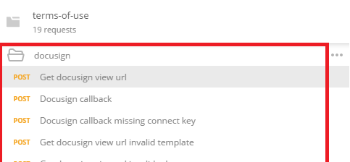

Get docusign view url

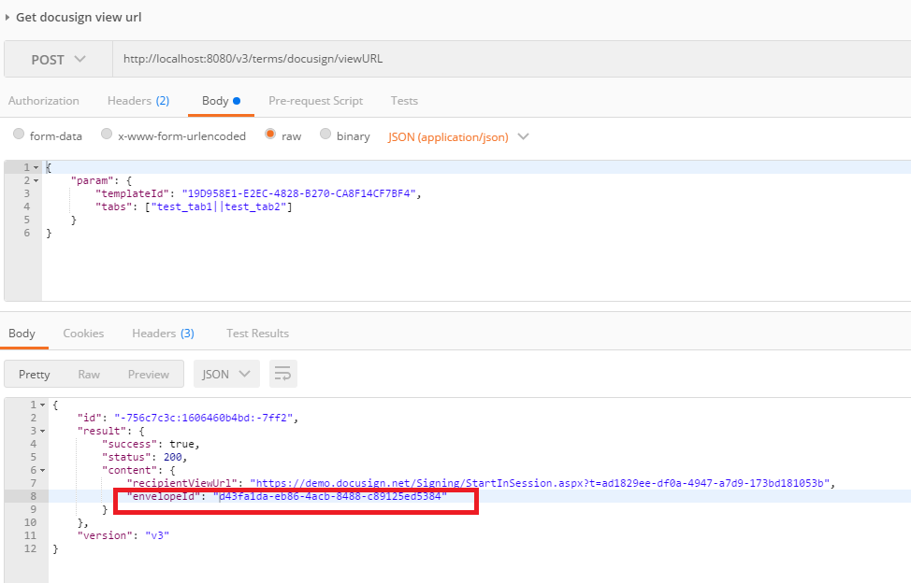

Copy the envelopeId above

Check the database:

select * from informixoltp:docusign_envelope;



select * from common_oltp:user_terms_of_use_xref;



Docusign callback

Use the envelope id from the response of Get docusign view url endpoint.

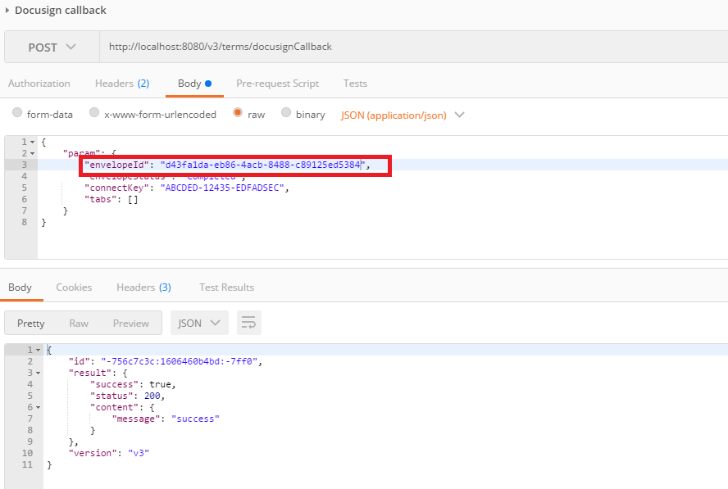

Check the database again:

select * from informixoltp:docusign_envelope;



select * from common_oltp:user_terms_of_use_xref;

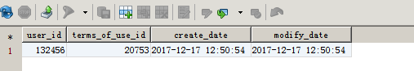

For the other endpoints for invalid parameter, check them similarly.